PR NUMBER Sizes: Large 50, Extra-large 20, medium 15, free size 15. Colours 50 White, 50 Orange
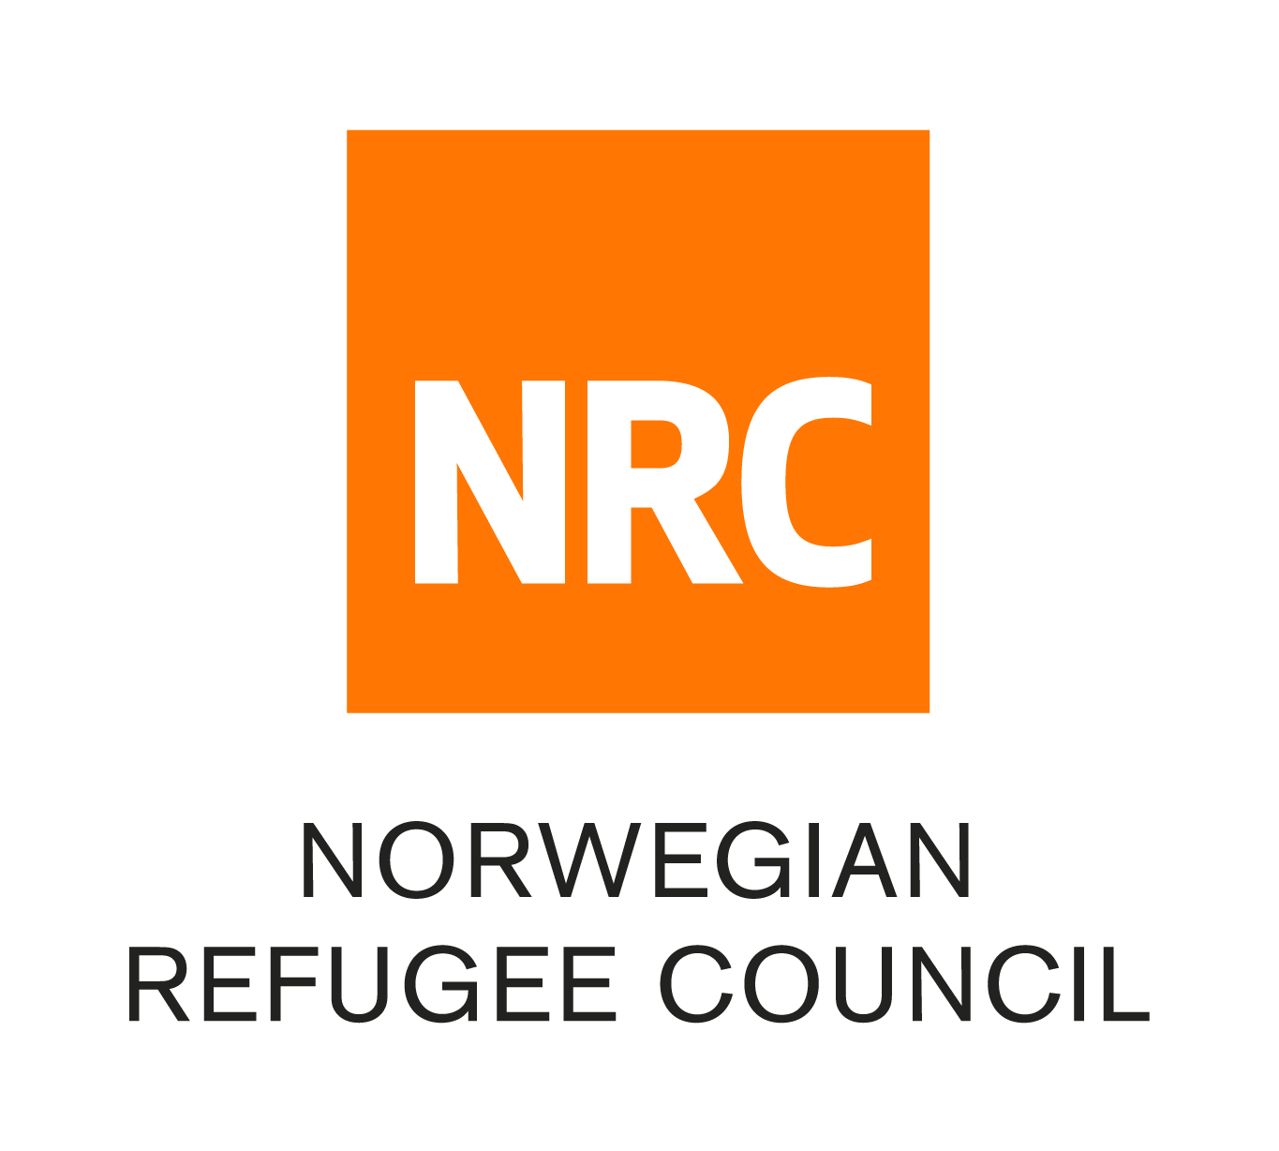

World Water Day 2023

Theme: Groundwater: Making the Invisible Visible

